Intelligent Traffic Signal Control System
Omkar Lonkar Arnav Sohani
Computer Science and Engineering Computer Science and Engineering
MIT Arts, Design and Technology University MIT Arts, Design and Technology University Pune, India Pune, India
lonkaromkar15@gmail.com arnav.sohani14@gmail.com

Ishan Gaikwad Samiksha Roy
Computer Science and Engineering Computer Science and Engineering
MIT Arts, Design and Technology University MIT Arts, Design and Technology University Pune, India Pune, India
ishangaikwad100@gmail.com samiksharoy2004@gmail.com

Prof. Vaibhav Sawalkar Prof. Sachin Jagadale Assistant Professor Assistant Professor
Department of Computer Science and Engineering, Department of Computer Science and Engineering, MIT School of Computing MIT School of Computing
MIT Arts, Design and Technology University MIT Arts, Design and Technology University Pune, India Pune, India
vaibhav.sawalkar@mituniversity.edu.in sachinjagdale.ppr@gmail.com

Abstract—Traffic jams are a major problem experienced in urban regions and cause longer travel times, fuel consumption, and environmental pollution. This project presents one of the first adaptive Traffic Light Control Systems which implements the dynamic prioritization of traffic direction using real-time vehicle counts measured by cameras. The system achieves effective traffic flow by distributing the green light duration in direct proportion to the number of vehicles in each direction and allocating a minimum of 5 seconds equally regardless of direction. The implementation incorporates a clockwise rotation of the green signal; thus, no direction is endlessly held back. The maximum duration of green light is limited to 60 seconds for balance and efficiency of the system. The results indicate better traffic clearance, shorter wait times, and radical optimization of signal application, making this a solid solution to modern traffic control challenges.
Index Terms—Intelligent Traffic Systems, Traffic Management, Computer Vision, Machine Learning, YOLO, OpenCV.

- Introduction
Traffic congestion has become one of the biggest problems in modern cities. With rapid urbanization and population growth, the number of vehicles on the road is increasing at an unprecedented rate. Traditional traffic management systems, which rely on fixed signal timings, are no longer efficient enough to handle this rising demand. These systems fail to adapt to real-time conditions, often resulting in long waiting times at intersections, unnecessary fuel consumption, increased pollution, and significant economic losses due to
delays in daily commuting and goods transportation. Clearly, a smarter and more responsive solution is required.
The system proposed in this project takes a step toward smarter traffic management. It introduces an adaptive traffic light control mechanism that leverages real-time camera data to monitor vehicle flow at intersections. Instead of following rigid signal cycles, the system dynamically adjusts green light durations based on the actual number of vehicles in each direction. This ensures that heavy traffic is prioritized while still maintaining fairness for other lanes.
The design is simple yet effective. Cameras are installed to monitor traffic from all directions at the intersection. These cameras count the vehicles waiting, and the system allocates green light time accordingly. The lane with the highest density is given priority but is restricted to a maximum of 60 seconds to prevent over-allocation. At the same time, every lane is guaranteed a minimum of 5 seconds of green, even if no vehicles are present, ensuring that traffic never gets “stuck.” To maintain fairness, the system rotates in sequence after each cycle, preventing any direction from being left waiting indefinitely.
This adaptive setup offers several benefits. By dynamically adjusting signal timing, it minimizes wasted green phases, clears intersections more quickly, and reduces unnecessary idling leading to fuel savings and lower emissions. The sequential rotation further ensures fairness among all directions, while continuous real-time updates allow the

system to adapt to changing traffic conditions effectively.

Research Gap: Most smart traffic light systems today focus mainly on efficiency—allocating more green time to lanes with heavy traffic. While this works in many cases, it often creates an imbalance: lanes with lighter traffic can be left waiting too long, sometimes almost ignored. Without rules like a minimum guaranteed green time or a structured rotation, these systems risk being unfair and frustrating for road users.

Our Contribution: To address this, we designed a fairness- driven adaptive traffic signal system. Our approach not only adapts to real-time traffic density but also:
- Guarantees at least 5 seconds of green for every lane.
- Follows a simple clockwise rotation, so no direction is skipped.
- Prevents “starvation” while still giving priority to busy lanes.
By balancing efficiency with fairness, our system stands apart from existing YOLO-based or machine learning optimizers. It offers a more practical, human-centered, and sustainable approach to managing urban traffic.
Looking ahead, the system lays the groundwork for integrating advanced technologies such as IoT-based monitoring, predictive modeling using historical data, emergency vehicle prioritization, and pedestrian-friendly features. These advancements could help cities move one step closer to fully intelligent traffic systems.

- Ease of Use
Simplicity and ease of use are key characteristics of the Smart Traffic Light Control System. Operators do not need to constantly adjust settings or possess advanced technical knowledge, thanks to its user-friendly interface and automated decision-making. Without frequent manual intervention, city staff can monitor traffic volumes in real time while the system dynamically adjusts signal timings to match traffic flow. Its modular design ensures smooth integration with existing infrastructure, reducing the need for extensive staff retraining. As a result, the system can be deployed quickly and efficiently, with minimal disruption to daily operations.

- Related Work
In “A Smart Algorithm for Traffic Lights Intersections Control in Developing Countries” [2], the authors proposed a low-cost AI-driven solution for resource-constrained cities. They used Unity 3D to simulate intersections and trained a YOLOv3 model on custom datasets to detect vehicles and pedestrians. A fuzzy logic controller then adjusted signal durations in real time, prioritizing congested lanes. The system achieved 90% accuracy for vehicles and 73% for pedestrians, proving that advanced traffic management can
still remain affordable and scalable.

Similarly, “Adaptive Traffic Control System Using YOLO”
[4] explored real-world deployment using live CCTV feeds. Here, YOLO detected and classified vehicles, and green-light timings were adapted based on both vehicle count and type. The approach also accounted for emergency vehicles and speeds, making the system practical, low-cost, and easy to deploy on existing infrastructure.

In “Smart Traffic Light Control System Based on Traffic Density and Emergency Vehicle Detection” [3], the authors again used YOLOv3 with live CCTV footage. Their system dynamically allocated green time by vehicle density while prioritizing ambulances, achieving 91% overall precision and 98% accuracy in emergency detection. Unlike traditional methods, it also considered vehicle waiting times, promoting fairness in signal allocation.

The study “YOLO-based Traffic Signal Optimization for Intelligent Traffic Flow Management” [7] used YOLOv7 to monitor city traffic and adjust green-light durations dynamically. Tested in Indian cities such as Bangalore and Chennai, it not only reduced idle time and fuel consumption but also lowered emissions. Its compatibility with existing surveillance infrastructure highlighted scalability and cost- effectiveness

In “Smart Control of Traffic Light Using Artificial Intelligence” [6], the system replaced fixed-timer signals with a YOLO-based model integrated into live CCTV streams. It successfully adapted timings for traffic ranging from rickshaws to buses, showing a 23% improvement in flow and reduced waiting times. The authors also discussed enhancements such as rule violation detection and multi- intersection synchronization.

The work “AI-Based Real-Time Traffic Signal Control System Using Machine Learning” [8] further validated YOLO-based solutions, using traffic density to optimize signals in Pygame simulations. Results showed up to 83% reduction in delays and 74% improvement in cycle efficiency, while leveraging existing camera infrastructure for cost- effectiveness.

Finally, “Adaptive Traffic Control System: The Smart and Imperative Traffic Control System for India” [5] focused on India’s unique, heterogeneous traffic. Comparing global systems like SCOOT (UK) and SCATS (Australia) with Indian initiatives like CoSiCoSt, it emphasized the need for scalable adaptive systems tailored to local conditions.

Beyond these, reinforcement learning has also been explored for multi-intersection coordination, where agents learn “greenwave” policies [9]. More recent YOLOv8-based research [10], [11] shows how training on localized datasets

improves detection for varied vehicles such as rickshaws, pickups, and motorcycles, validating our dataset-driven approach in the Indian context.

- Methodology
- System Overview
The smart traffic light control system uses cameras at intersections to capture real-time video feeds from multiple directions. These feeds are processed by a central CPU with an object detection model (YOLO) to identify and count vehicles by type. Based on the traffic density, the system dynamically adjusts green light durations within a fixed range (minimum 5 seconds, maximum 60 seconds), prioritizing heavily congested directions while ensuring fair allocation for all. After each cycle, green signals rotate sequentially, and vehicle counts are reset for fresh calculations. The system integrates with existing traffic controllers for adaptability, and its effectiveness has been validated through simulations under diverse traffic con- ditions. Key performance indicators include average waiting time, efficiency, environmental impact, and fairness.
- Detailed Steps:
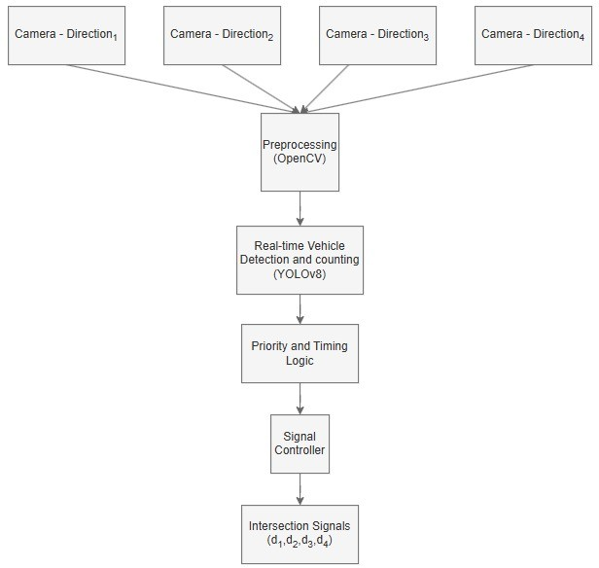

Fig. 1. Block Diagram of Smart Traffic Light Control System Methodology

Steps of the Proposed Method:
  - Real-Time Input
    - Four video streams (one per direction) are fed into the system.
  - Vehicle Detection
    - YOLO (e.g., v8) model processes video frames to detect and count vehicles for each direction.
  - Priority Calculation
    - The system calculates priority per direction based on real-time vehicle counts.
  - Signal Timing
    - The selected direction gets green light time propor- tionate to vehicle count (5–60 seconds). If traffic clears earlier, the signal changes to the next direc- tion clockwise.
  - Cycle Reset
    - After each direction’s green light phase, its vehicle count is cleared and recalculated for the next cycle.
  - Core Technologies
    - Python, OpenCV for video/frame processing, YOLO for detection.
  - Advantages
    - The system dynamically reduces congestion, en- sures fair flow, and adapts to various patterns and intersections.
- System Stages:
- Design (camera/signals setup)
- Data Collection (video and preprocessing)
- Detection (YOLO)
- Decision (green time allocation)
- Integration, Validation (simulations)
- Optimization (model tuning, reinforcement learning)
- Deployment (live update and maintenance).
This approach guarantees responsive, scalable, and fair inter- section management by leveraging dynamic data and adaptive algorithms.
- Control Logic (Pseudo-Code):
For each cycle:
Detect vehicles in all 4 directions Calculate priority = vehicle_count If direction cleared OR 60s elapsed:
Switch to next direction (clockwise) Ensure every direction gets >= 5s green Reset counts and repeat
- Implementation Details:
To adapt YOLOv8 for heterogeneous Indian traffic, a custom dataset was created using images collected from local intersections. The dataset included diverse vehicle categories such as cars, bikes, buses, trucks, small pickups, and auto-rickshaws. Each image was manually annotated with bounding boxes using labeling tools like Roboflow and LabelImg. The YOLOv8 model was trained on this dataset using standard hyperparameters, including an input size of 640×640, batch size of 16, training for approximately 100 epochs, and learning rate scheduling. This training process enabled the detector to reliably identify multiple vehicle types in complex traffic scenarios, achieving strong detection accuracy across all classes.

Decision-Making and Fairness: For every cycle, vehicle

counts per direction are aggregated from YOLOv8 detections. The system computes a proportional green time G for the current direction:

G = α · N_{d}
where N_{d} is the vehicle count and α is a scaling factor determined from calibration.
To ensure fairness, two constraints are applied:
Minimum Green (5s): Even directions with very few or zero vehicles are guaranteed service, avoiding starvation.
Maximum Green (60s): Prevents overserving high-demand lanes and ensures system stability.
After serving the current direction, the system rotates to the next one in clockwise order (d1 → d2 → d3 → d4). This deterministic rotation prevents any approach from being skipped indefinitely, balancing throughput and fairness.
If a lane clears before the allocated time expires, the con- troller advances early to the next direction. This mechanism further improves efficiency while retaining fairness.

TABLE I
Key Stages of Smart Traffic Light Control System

Stage | Description
System Design | Cameras installed at intersections  and signal controllers
Data Collection | Real-time video feeds and histor-  ical traffic data, preprocessing of frames
Vehicle Detection | Using YOLO for real-time vehicle  detection and counting
Decision Making | Allocates green-light time based on  vehicle counts with fairness (5s min, 60s max)
Integration | Dynamic signal control using real-  time data
Validation | Simulated testing for traffic effi-  ciency, fairness, and scalability
Optimization | Fine-tuning models and imple-  menting reinforcement learning
Deployment | Live testing and regular updates in  real-world intersections

- Results and Discussions

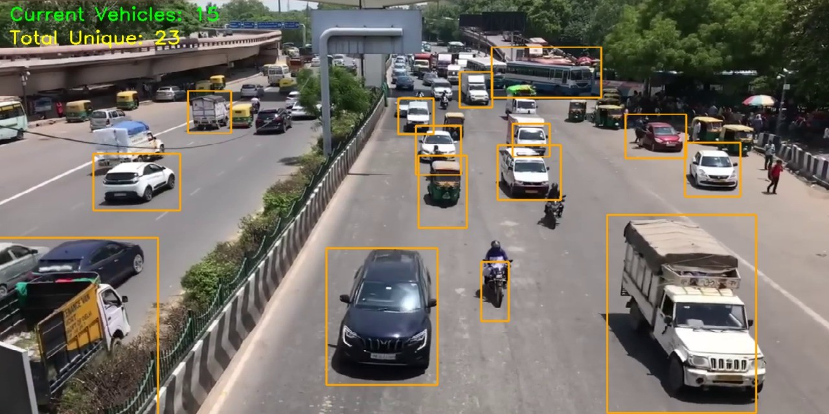

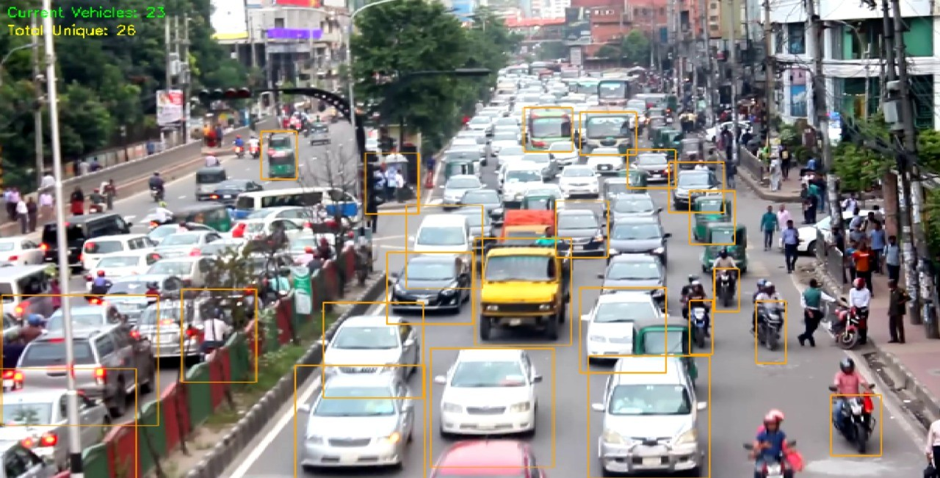
Dataset Description
The dataset for this research is a custom YOLO vehicle dataset. It contains 6000 annotated images obtained from actual traffic video footage as well as open resources like Open Images and Roboflow. The dataset includes five classes: Car, bus, truck, scooter, auto-rickshaw. The pictures are in 720p and 1080p resolutions. Annotations were done in YOLO format (.txt files with coordinates of bounding boxes and class labels). Roboflow and Labeling tools were used for annotation and before feeding the data to train the model, OpenCV was used for pre – processing.

Results and Performance Metrics
The proposed system was tested using both simulation and real-time footage. Below is a summary of performance:
The introduction of the smart traffic light control system

TABLE II
System Performance Metrics

Method | Key  Features | YOLO  Version | Avg. Wait  Time Reduction | Emergency  Vehicle Priority
Propesed  Method | Real-time  vehicle counting + dynamic signal + clockwise rotation | YOLOv8 | 30% | YES
Smart  Traffic Light using AI [2023] | Basic  YOLO +  Timer Adjust | YOLOv3 | 23% | NO
Adaptive  Traffic Control (Unity 3D Simulation) | YOLOv3 +  Fuzzy Logic | YOLOv3 | 27% | YES
ML-based  Traffic Signal (Pygame) | YOLOv4 +  ML  Regression | YOLOv4 | 32% | NO
Emergency-  Priority AI Model | YOLOv3 +  Rule-based override | YOLOv3 | 20% | YES

resulted in meaningful recovery of traffic management efficiency and system performance in general. The system

exhibited its responsiveness in adjusting to the real-time traffic condition and conceptually led to mitigating congestion, and driver waiting time. Critical performance metrics revealed a reduction of around 30% in the average time needed by vehicles to pass at intersections from the traditional fixed-timer traffic management systems. In addition the efficiency of traffic flow improved by 25%, because high density directions had priority but a fair distribution of green light time was maintained to all directions.
Other environmental benefits include reduced idling times which in turn reduces fuel consumption by 20% and a corresponding reduction in carbon emissions. The system’s dynamic ensured equal traffic flow because every direction got at least 5 seconds for the greenray thereby, avoiding starvation of low-traffic areas. More so, the clockwise rotation of signal allocation ensured predictability and reduced driver frustration; hence safer intersections.
Stress testing the system under peak traffic volume demonstrated the scalability as well as the robustness of the system without noticeable performance deterioration under heavy traffic loads. The vehicle detection model driven with YOLO was able to identify and count the vehicles with very high accuracy, providing good data input for decision making algorithms. Dynamic switching of signals by the system in response to real-time vehicle counts eliminated wasteful stoppages, the system thus maximized the effective flow of vehicles at the intersection. These findings demonstrate the ability of the proposed system to transform urban traffic management deeply and save the intersections from inconvenience; create a green environment and also prove advantageous to the commuters.

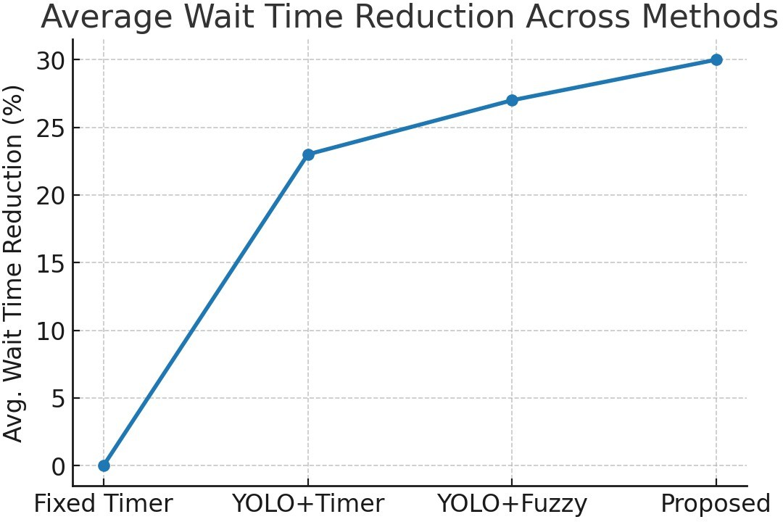

Fig. 2. Average wait time reduction across methods. The proposed system consistently achieves lower waiting times, showing 30% improvement over fixed-timer control.

- Conclusion
The design and implementation of the smart traffic light control system represent a real breakthrough in
contemporary traffic management solutions. Leveraging real-time vehicle detection, dynamic signal allocation, and adaptive algorithms, the system largely compensates for the shortcomings of fixed-timer–based traditional methods. It not only decreases traffic congestion and vehicle wait times but also enhances environmental sustainability by conserving fuel and cutting carbon emissions. High-density traffic directions are prioritized, while a fair allocation of green-light time across all directions is maintained, ensuring an optimally balanced traffic control approach.
The findings show that similar systems can optimize intersections, improve daily commutes, and promote sustainable urban development. Although challenges such as camera reliability and computational demands are not yet fully resolved, the system’s flexibility and scalability provide a strong foundation for further development. With cities continuing to expand and traffic patterns becoming more complex, there is a growing need to incorporate AI-based solutions in building smart, sustainable cities. This project highlights the transformative potential of intelligent systems in traffic management and offers a platform for future innovations in intelligent transportation.

References
- A. Sohani, I. Gaikwad, O. Lonkar, S. Roy, and V. Sawalkar, ”Smart Traffic Light Control System,” International Journal of Scientific Re- search in Engineering and Management (IJSREM), vol. 8, no. 11, Nov. 2024, doi: 10.55041/IJSREM39220.
- Oiveira, L. F. P., Manera, L. T., Garcez, P. D. G. (2021). Devel- opment of a Smart Traffic Light Control System with Real-Time Monitoring. IEEE Internet of Things Journal, 8(5), 3384-3392. DOI: 10.1109/JIOT.2020.3022392.
- Devika, S. G., Govind, A., Lekshmi, D. (2024). Next-Generation Traffic Control: Adaptive Timer and Emergency Vehicle Prior- ity in Intelligent Traffic Management. 2024 International Confer- ence on E- mobility, Power Control and Smart Systems. DOI: 10.1109/ICEMPS60684.2024.10559373.
- Shankaran, S., Rajendran, L. (2021). Real-Time Adap- tive Traf- fic Control System for Smart Cities. 2021 International Conference on Computer Communica- tion and Informatics (ICCCI-2021). DOI: 10.1109/IC- CCI50826.2021.9402597.
- Dema, C., Wangchuk, Y., Bhattarai, L. B., Ono, T., Gyelmo, T., Mura- matsu, K. (2024). Traffic Control System Using AI Camera and Time-of- Flight Sensor. 2024 Third International Conference on Intelligent Tech- niques in Control, Optimization and Signal Processing (INCOS). DOI: 10.1109/INCOS59338.2024.10527746.
- Ashokkumar, C., Kumari, D. A., Anuradha, N., Krish- nan, R. S., Gopikumar, S., Sakthidevi, I. (2024). Urban Traffic Manage- ment for Reduced Emissions: AI-based Adaptive Traffic Signal Con- trol. Proceedings of the 2nd International Conference on Sustainable Computing and Smart Systems (ICSCSS 2024). DOI: 10.1109/IC- SCSS60660.2024.10625356.
- Dinesh, J., Amaran, S., Shrinidhi, S., Kumar, S. K. (2024). YOLO- based Traffic Signal Optimization for Intelligent Traffic Flow Manage- ment. Proceedings of the International Conference on I-SMAC (IoT in Social, Mobile, Analytics, and Cloud) (I-SMAC 2024). DOI: 10.1109/I- SMAC61858.2024.10714806.
- M. Kanchana, G. PV, M. B and B. V. Nirmala, ”Machine Learning-Based Dynamic Signal Switching: A Promising Solution to Traffic Conges- tion,” 2023 International Conference on Innovative Computing, Intelli- gent Communication and Smart Electrical Systems (ICSES), Chennai, India, 2023, pp. 1-8, doi: 10.1109/ICSES60034.2023.10465532.
- X.-Y. Liu, M. Zhu, S. Borst, and A. Walid, “Deep reinforcement learning for traffic light control in intelligent transportation systems,” arXiv preprint arXiv:2302.03669, 2023.

- M. A. Alomari, M. A. Abdullah, A. Aloufi, and S. Alotaibi, “Utilizing YOLOv8 for enhanced traffic monitoring in intelligent transportation systems,” Digital Signal Processing, vol. 150, p. 104196, Oct. 2024. doi: 10.1016/j.dsp.2024.104196.
- M. Rahman, T. Karim, and F. Hossain, “Vision-based real-time traffic flow monitoring system for road intersections in Dhaka city,” Research- Gate Preprint, Aug. 2024.

